ICTWEB513 - Q1.9

# Table of contents

# 

**Table of contents** **2**

**Executive summary** **3**

**Facebook webpage** **4**

Wireframes 4

Branding 6

Colour 6

Light/dark version 8

Database 9

Page layout 11

Page flow 12

# 

# Executive summary

This is a step-by-step manual document on testing the food recipes website.

# Usability tests

We are testing the website against usability to identify issues and possible improvements on navigation flow and ease of use.

We are checking all the links and buttons.

## Results:

The footer section of the home page has a link to a FAQ page but it is linked to the contact us page.

The other pages are correct.



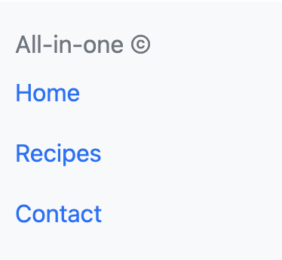

Some of the components have no navigation flow or have no functionality implemented:

* Order now button  
  
* Filter buttons  
  
* Send button  
  

# Functional tests

Verify whether the product meets the intended functional specifications mentioned in your development documentation.

## Front-end

Some of the component functionalities are not yet implemented such as:

* Order now button  
  
* Filter buttons  
  
* Send button  
  

## Back-end

The current version of the website has no back-end implemented.

# Compatibility Tests

In order to determine if your software is compatible with other elements of a system with which it should operate, e.g., Browsers, Operating Systems, or hardware, we are running compatibility tests.

## Results:

Chrome - ok

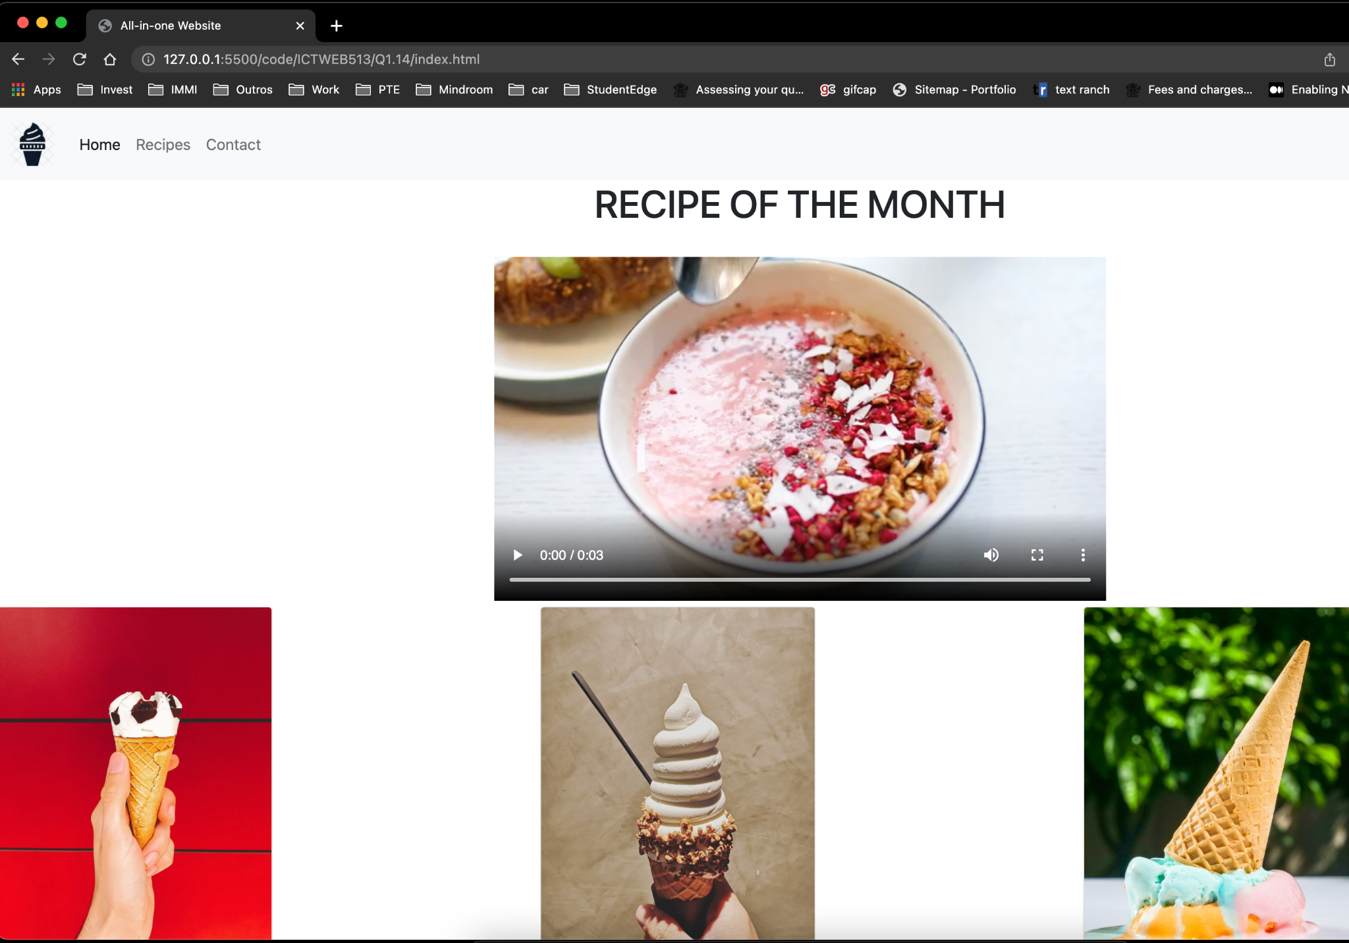

Safari - ok

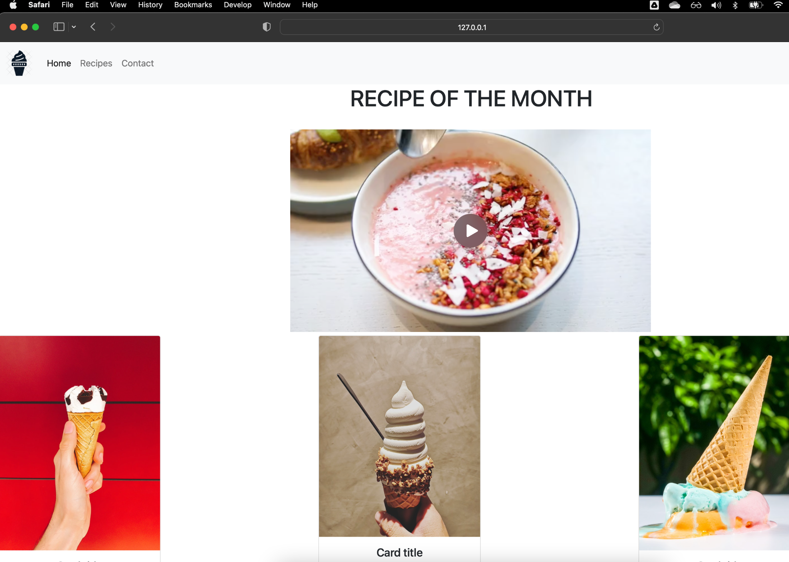

Mobile - nok

Video extrapolate the size of the screen or the other components padding is incorrect:

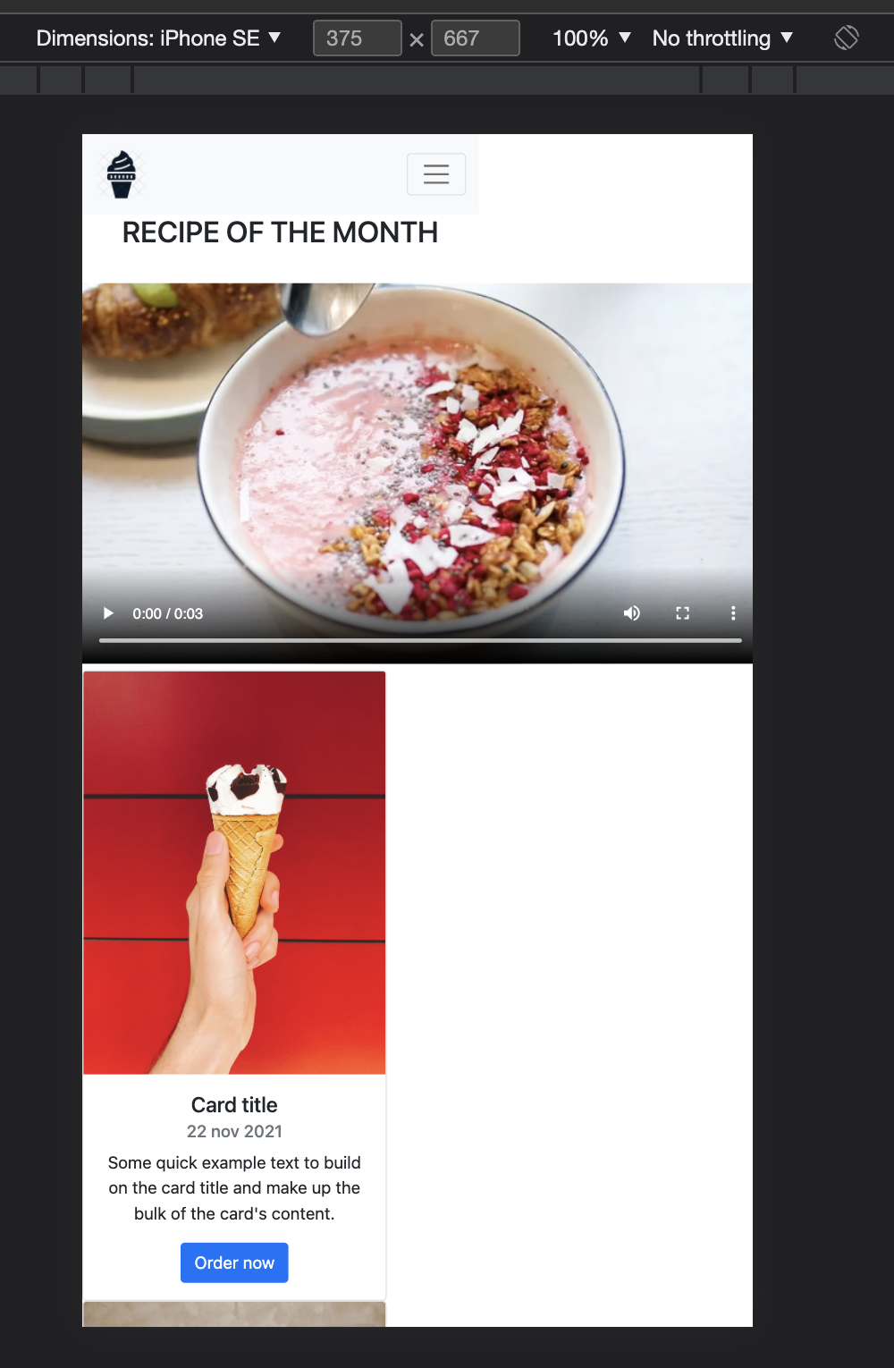

# Database Tests

The current version of the website does not have a database.

# Security tests

The current version of the website does not have any sensitive data or security issues.

# 

# Performance tests

The current version of the website is not available online, only local, therefore, we run no performance tests.